**List of Experiments using MATLAB**

1. **Amplitude modulation and demodulation**
2. **Dual Side Band – Suppressed Carrier modulation and demodulation**
3. **Frequency modulation and demodulation**
4. **Pulse Code Modulation and Demodulation**
5. **Delta Modulation and Demodulation**
6. **Phase Shift Keying Modulation and demodulation**
7. **Quadrature Phase Shifty Keying Modulation and Demodulation**

|  |  |  |
| --- | --- | --- |
| **Date:** | **Experiment 1**  **Amplitude Modulation and Demodulation** | **Time:** |

**Aim:**

To study the function of Amplitude Modulation & Demodulation and also to calculate the modulation index

A comprehensive study on Under Modulation, Exact Modulation and Over Modulation of signals

**Hardware Requirement:**

* + PC with Windows 8 and above
  + MATLAB Software R2019 & above with communication toolbox

**Methodology:**

* + Modulation is defined as the process of changing the characteristics (Amplitude, Frequency or Phase) of the carrier signal (high frequency signal) in accordance with the intensity of the message signal (modulating signal)
  + Amplitude modulation is defined as a system of modulation in which the amplitude of the carrier is varied in accordance with amplitude of the message signal (modulating signal)
  + Initialize the message signal **m** with amplitude Vm and frequency fm (usually considered as low frequency)
  + Initialize the carrier signal **c** with amplitude Vc and frequency fc (usually considered as low frequency)
  + Obtain the amplitude modulation of the signals **s1, s2 and s3** with different modulation indexes **Am = 1, 2 and 5** respectively
  + Demodulation: Separate message signal from modulated signal by multiplying it with carrier signal and then apply filtering techniques
  + Plot the message signal, modulated signal and demodulation signal
  + Analyze the Amplitude Modulation with different modulation index

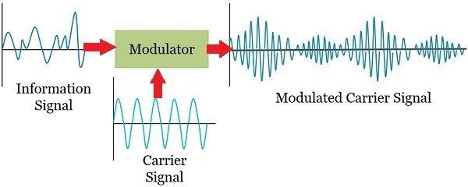

**(a)Modulation Process**

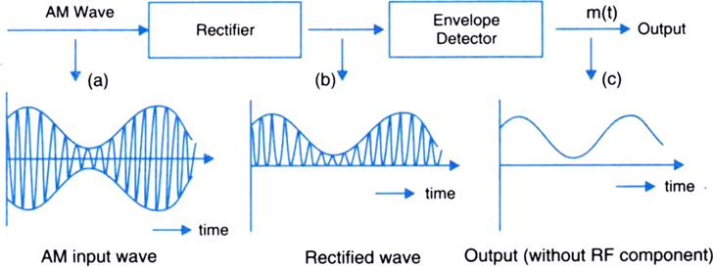

**(b)Demodulation Process**

**Inference**

**Result**

**Signature of Facutly**

|  |  |  |
| --- | --- | --- |
| **Date:** | **Experiment 2**  **Dual Side Band – Suppressed Carrier Modulation and Demodulation** | **Time:** |

**Aim:**

To perform the AM DSB-SC signal Generation and Detection using MATLAB. To generate DSB-SC AM signal using balanced modulator. Calculate the modulation index and reconstruct the modulating signal using synchronous detector

**Hardware Requirement:**

* + PC with Windows 8 and above
  + MATLAB Software R2019 & above with communication toolbox

**Methodology:**

* + Balanced modulator is used for generating DSB-SC signal.
  + A balanced modulator consists of two standard amplitude modulators arranged in a balanced configuration so as to suppress the carrier wave.
  + The two modulators are identical except the reversal of sign of the modulating signal applied to them
  + Analyze the Amplitude Modulation with dual sideband and suppressed carrier

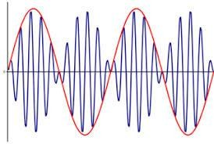

**(a) Modulation Process**

**Inference**

**Result**

**Signature of Facutly**

|  |  |  |
| --- | --- | --- |
| **Date:** | **Experiment 3**  **Frequency Modulation and Demodulation** | **Time:** |

**Aim:**

To generate frequency modulated signal and determine the modulation index and bandwidth for various values of amplitude and frequency of modulating signal

To demodulate a Frequency Modulated signal using FM detector

**Hardware Requirement:**

* + PC with Windows 8 and above
  + MATLAB Software R2019 & above with communication toolbox

**Methodology:**

* + Frequency Modulation is a process in which the frequency of the carrier signal is varied in accordance with the amplitude of the base band signal provided that the amplitude of the carrier signal is kept constant
  + In AM, as the modulation index increases, the transmitted power increases while the transmitted power is independent of the modulating index in FM.
  + Detection or demodulation is the process of retranslation of the spectrum to its original position.
  + The method of recovering the original baseband signal is called detection or demodulation of an FM signal.
  + The modulation index for FM is defined as Mf= max frequency deviation/ modulating frequency

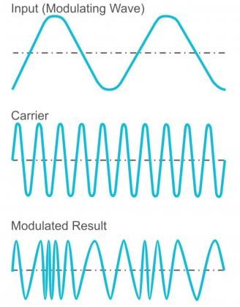

**(a)Modulation Process**

**Inference**

**Result**

**Signature of Facutly**

|  |  |  |
| --- | --- | --- |
| **Date:** | **Experiment 4**  **Pulse Code Modulation and Demodulation** | **Time:** |

**Aim:**

To convert an analog signal into a pulse digital signal using PCM system and to convert the digital signal into analog signal using PCM demodulation system.

**Hardware Requirement:**

* + PC with Windows 8 and above
  + MATLAB Software R2019 & above with communication toolbox

**Methodology:**

* + In the PCM communication system, the input analog signal is sampled and these samples are subjected to the operation of quantization.
  + The quantized samples are applied to an encoder.
  + The encoder responds to each such a sample by generation unique and identifiable binary pulse.
  + The combination of quantize and encoder is called analog to digital converter.
  + It accepts analog signal and replaces it with a successive code symbol, each symbol consists of a train of pulses in which each pulse represents a digit in arithmetic system.
  + When this digitally encoded signal arrives at the receiver, the first operation to be performed is separation of noise which has been added during transmission along the channel.
  + It is possible because of quantization of the signal for each pulse interval; it has to determine which of many possible values has been received.

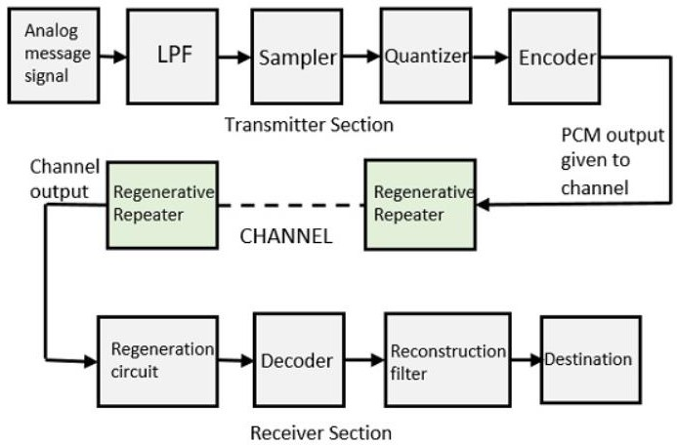

1. **PCM Modulation & Demodulation Process**

**Inference**

**Result**

**Signature of Facutly**

|  |  |  |
| --- | --- | --- |
| **Date:** | **Experiment 5**  **Delta Modulation and Demodulation** | **Time:** |

**Aim:**

To study the Delta Modulation process by comparing the present signal with the previous signal of the given Modulating signal.

**Hardware Requirement:**

* + PC with Windows 8 and above
  + MATLAB Software R2019 & above with communication toolbox

**Methodology:**

* + Delta Modulation is a Differential Pulse Code Modulation Technique, in which the difference signal between two successive samples is encoded into a single bit code
  + This is also known as Linear Delta Modulator
  + The signal m(t) is the analog input signal
  + While r(t) is a reconstructed signal which is same as the quantised input signal with 1 bit delay
  + The signal r(t) tries to follow the input signal m(t) with one bit period delay
  + The comparator compares the input signal m(t) and r(t)
  + If m(t) > r(t) a logic 1 is generated at the output of the comparator, otherwise a logic 0 is generated
  + The value of logic 1 or logic 0 turned as ∆(t) is held for the bit duration by the sample and hold current to generate So(t), the Delta Modulated Output
  + This output So(t) is fed to the 8 bit binary up/down counter to control it’s count direction
  + A logic 1 at the mode control input increases the count value by one and a logic ‘0’ decrements the count value by one
  + All the 8 outputs of the counter are given to DAC to reconstruct the original signal
  + Delta demodulator works in the same way as it was in the feedback loop of the Delta modulator
  + The received Delta modulated signal So(t) is given to the mode control input (U/ D) of the up/ down counter
  + The counter is 8 bit wide and counts in binary fashion
  + All the 8 outputs are connected to an 8 bit DAC which gives a quantised analog signal (stepped waveform)
  + A low pass filter is used to smooth out the steps
  + A buffer amplifier provides the necessary drive capability to the output signal
  + Thus the digital Delta modulated data is demodulated and reconstructed into an analog signal

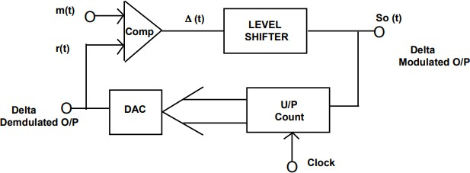

**(a)Delta Modulation Transmitter**

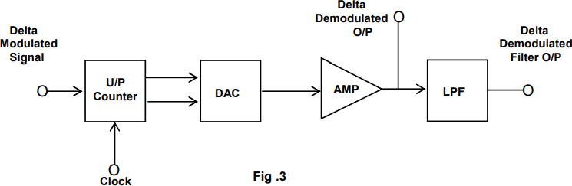

**(b)Delta Demodulation Receiver**

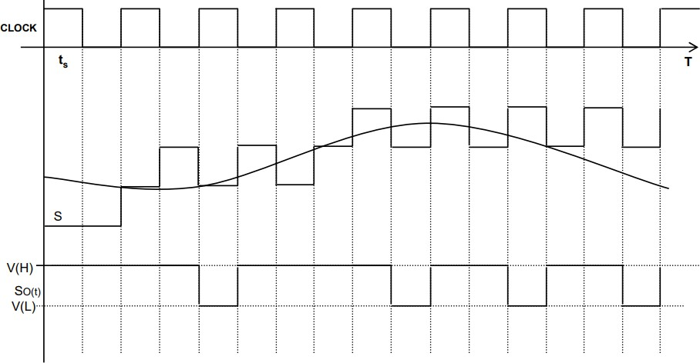

**(c)Response of Delta Modulation to a Baseband Signal**

**Inference**

**Result**

**Signature of Facutly**

|  |  |  |
| --- | --- | --- |
| **Date:** | **Experiment 6**  **Phase Shift Keying Modulation and Demodulation** | **Time:** |

**Aim:**

To study the Binary Phase Shift Keying modulation and demodulation process by comparing the present signal with the previous signal of the given Modulating signal.

**Hardware Requirement:**

* + PC with Windows 8 and above
  + MATLAB Software R2019 & above with communication toolbox

**Methodology:**

* + The PSK is a form of angle modulated, constant amplitude digital modulation
  + Digital communications because important with the expansion of the use of computers and data processing, and have continued to develop into a major industry providing the interconnection of computer peripherals and transmission of data between distant sites
  + Phase shift keying is a relatively new system, in which the carrier may be phase shifted by +90 degree for a mark, and by-90 degrees for a space
  + PSK has a number of similarities to FSK in may aspects, as in FSK, frequency of the carrier is shifted according to the modulating square wave
  + In Phase shift keying (PSK), the phase of the carrier is modulated to represent the binary values
  + The carrier phase change between 0 and 𝜋 by the bipolar digital signal. Binary states “1” and “0” are represented by the positive and negative polarity of the digital signal

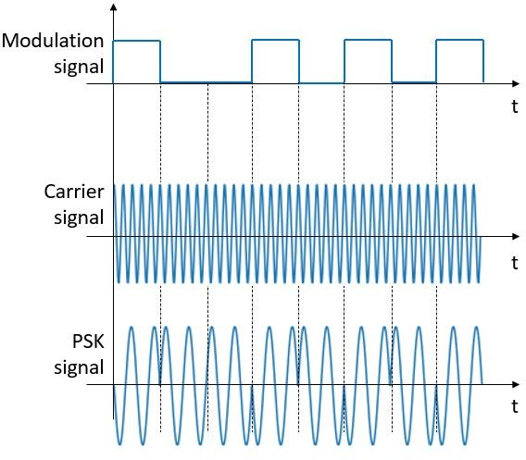

1. **BPSK Modulation**

**Inference**

**Result**

**Signature of Facutly**

|  |  |  |
| --- | --- | --- |
| **Date:** | **Experiment 7**  **Quadrature Phase Shift Keying Modulation and Demodulation** | **Time:** |

**Aim:**

To study the process Quadrature Phase Shift Keying Modulation and Demodulation by comparing the present signal with the previous signal of the given Modulating signal.

**Hardware Requirement:**

* + PC with Windows 8 and above
  + MATLAB Software R2019 & above with communication toolbox

**Methodology:**

* + QPSK is also known as quaternary PSK, quadriphase PSK, 4-PSK, or 4-QAM
  + It is a phase modulation technique that transmits two bits in four modulation states
  + Phase of the carrier takes on one of four equally spaced values such as π/4, 3π/4, 5π/4 and 7π/4
  + Each of the possible value of phase corresponds to a pair of bits called dibits.
  + Thus, the gray encoded set of dibits: 10,00,01,11
  + The four message points are

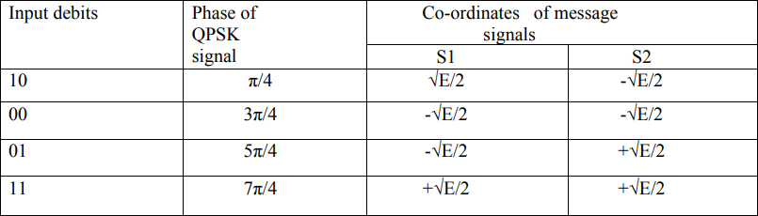

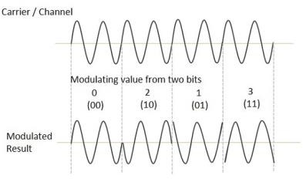

**(a) QPSK Modulation**

**Inference**

**Result**

**Signature of Facutly**